# Requirements

## Introduction

Here I will be analyzing two similar websites, gathering the pros and cons from each and then taking this information to users. I will be interviewing and surveying the target users to gauge their interest in the proposed features. After this user data has been collected, I will then proceed to refine the proposed features and alter where needed to fit the target users needs.

## Requirements gathering

### Similar applications

#### *Studytogether.com*

This platform focuses mainly on traditional study, offering goal checklists (see *figure 2)*, group or solo study rooms as well as a community aspect of leaderboards and events. The dashboard (*see figure 1*) immediately gives the user options to join a study room, make their own or study solo.

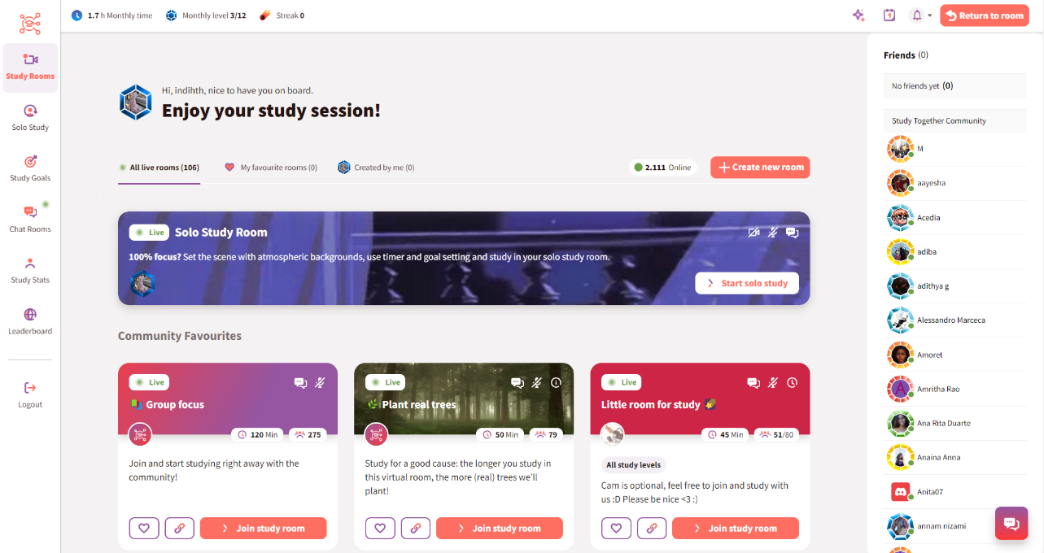

*Figure 1 - Dashboard*

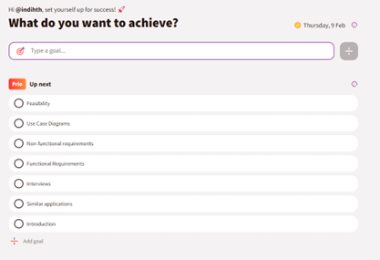

*Figure 2- Goal lists*

There are a few community engagement areas such as the challenges (*see figure 3)* and the leaderboard (*see figure 4)*. Each month the platform runs challenges to encourage users to study more or create new habits. The leaderboard ranks users monthly and can also be set to ‘Friends Only’, which is a particularly nice option and gives the opportunity to create a more personal study group.

Text Box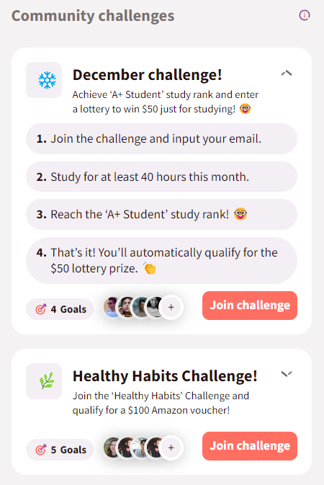

*Figure 4 - Leaderboard*

The platform has a more in-depth statistics view page (*see figure 4*) which gives users a chart which can be filtered by day, week, month or all time study hours. There is also badges and stones users can collect by logging more study hours along with a weekly streak tracker. The streak settings can be changed to require less or more time spent studying each day.

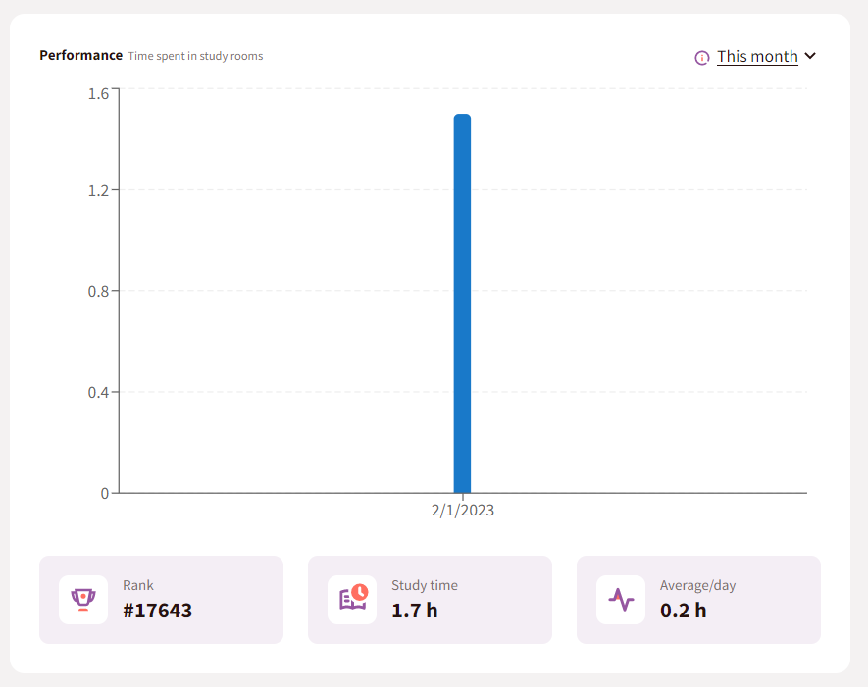

*Figure 5 - Statistics*

*Figure 6 - Statistics 2*

There’s a nice mini statistics section at the top left of the screen (*see figure 7*) where users can quickly see their total study hours of that month, their level and their study day streak. These small elements are great for motivation and show the user their progress in a quick snapshot, encouraging them to continue.

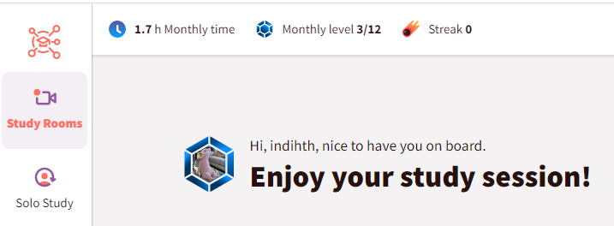

*Figure 7 - Mini Stats*

An interesting aspect of the platform is that in many places there are little info popups (*see figure 9*) and sections explaining the theory (*see figure 8*) behind parts of the platform.

Advantages:

* Easy goal setting with the option to create multiple lists of goals. For example, goals for each study subject, for the week or the month.
* Info points throughout the platform so the users understand why the included features are beneficial.
* The study and streak stats are great for users to view their progress. The streak is a way to gamify the process but also rewards consistency, regardless of the total amount. Badges and other earned rewards are also good for keeping engagement up.
* Community engagement with leaderboards, either global or friends only, can be motivating for users and gives goals to work towards, i.e., getting higher on the leaderboard.

Disadvantages:

* There’s no option to input hours studied outside of the platform or for other activities, which for traditional study is fine but not for the purposes of this project.
* There is no way to filter the study rooms currently online. A user may only want to view rooms where a webcam is mandatory or vice versa. Currently, the only option is to scroll and read each description.
* The leaderboard is just one huge pool of users. There are no league options to work up to. This could be discouraging for some users who will never want or be able to study 160hrs per month. A league system would motivate users to push just a little more within their current level. For example, a user in a level 3 league who studies 15hrs per month may work to be at the top of that league by increasing to 17hrs. Small and sustainable improvements are much more helpful than sudden, lofty goals. Being ranked #12255 isn’t going to be motivating for most users. Duolingo’s league system is quite good as it encourages just a little more than the user is currently doing.

#### *StickK*

This platform uses financial sakes to keep people on track with their goals. Setting up a commitment requires users to decide if they want to put money on the goals or not, and who will get that money if they fail. The options vary but it’s recommended people choose an ‘anti-charity’ to be the recipient if they fail. Anti-charities being something that the person strongly disagrees with, such the NRA for people who are against gun violence. This is meant to further motivate people to stick to their goals, otherwise their money goes to an organization they dislike. The platform also gives the option for a referee and the frequency of check-ins. The referee is sort of like an accountability partner as they must verify the user has completed their daily/weekly goals. Users can submit journal updates with photos to help keep them on track (*see figure 10*).

*Figure 10*

There is very little community on this platform because the motivation is solely financial so community is less important but it would be nice to see options to search for and connect with users of similar goals.

*Figure 11*

Advantages:

* If used correctly, extremely motivating as negative consequences are involved.
* Easy to setup, the process of making a new commitment was straight-forward.
* Clear ways to check-in/report daily activities were done.

Disadvantages:

* The platform doesn’t have many options once a commitment is made but for its model that isn’t necessary.
* The design is quite boring and slightly dated looking.

### Interviews

**Issue 1# - Ease of logging**

I interviewed someone with experience in food tracking, using an app. The main takeaways were that it took some time to get used to but the app made it easier by saving the most recent entries for each meal logging. For example, she ate the same thing for breakfast every day so that app would have that food be her first option when inputting breakfast. This made the whole process much easier, removing barriers and pain points. When entering new foods you just have to select the portion size or amount. There’s also recipes pre-filled for easy adding of common meals.

**Issue 2# - Predictions**

Another helpful feature she found was how the app would give her a prediction at the end of each day. For example, if she had eaten 1300 calories that day, the app would say “If you keep to this diet for 5 weeks you will have lost x amount of weight.” This feature could be used in relation to building skills, e.g if someone logged, they’d read for 20 minutes/x number of pages, the site could tell them “If you read this much every day, in x weeks you’ll have finished x book/read for x number of hours.”

From this interview I had a few ideas on how to make it easy for users to add their frequent activities to their logs and give them a prediction based on their current level of activity.

**Issue 3# - Tracking is counterproductive for some**

From the questionnaire I shared with a language learning community I found that some people didn’t find tracking their time helpful in the long run because they became too focused on getting their numbers up for the sake of numbers, not for their learning. To counter this, I would like to give the option for people to simply track their habits rather than their time. Each user should be given the option to use checkboxes or more in-depth time tracking. A simple checkbox would help users with the streak portion of tracking and not distract them with numbers.

*Questionnaire link:* [*https://forms.office.com/e/fQu2FGBUSQ*](https://forms.office.com/e/fQu2FGBUSQ)

## Requirements modelling

### Functional requirements

1. Allow creation of multiple daily tasks that can be checked off each day
2. Input time spent on each goal
3. Allow premium users to create multiple categories of goals (language, fitness etc.) and have different partners for each goal
4. View statistics for activities logged
5. View partners activity log
6. Comment/respond to partner's log

### Non-functional requirements

1. Notify user when their partner logs an activity
2. Track the users streak (consecutive days of study)
3. Ability to choose just checkboxes or time tracking on goals
4. Auto suggest the users more recent task when logging something
5. Let user pick logged media from a general index available to all on site
6. Give users a prediction of level in x weeks each time they log something

### Use Case Diagrams

This use case diagram illustrates what functions each user type can perform. The standard user is able to add new tasks, tick them off and view their and their partners’ history. The premium user can do all of this and add multiple goals. The admin can add new media (tv shows, movies etc.) to the index for users to select from, assign and remove partners and view any user history.

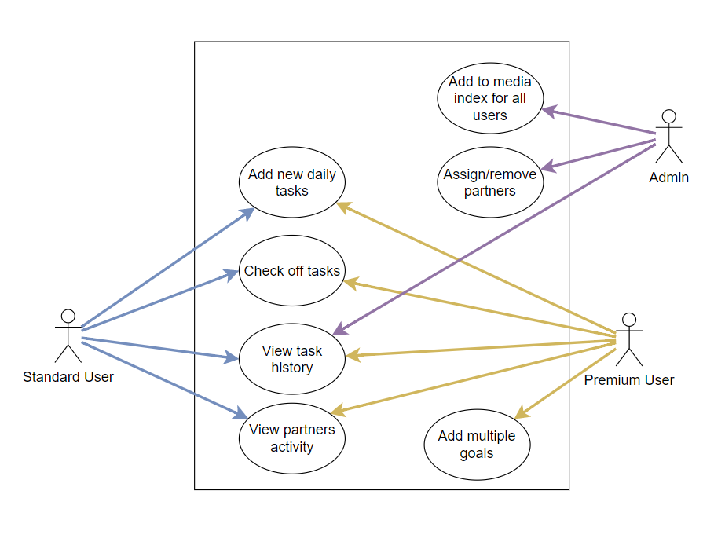

## Feasibility

The technologies to be used are the PHP framework Laravel, along with Breeze for authentication for the back-end, the Bootstrap framework for CSS and SCSS for front-end and SQL with phpMyAdmin for the database. I don’t foresee any complications with these technologies as I have used them together in the past with no compatibility issues. The scope of the project would be too wide if I were to attempt to match users with partners. With this in mind I will proceed assuming that each users has already been matched with a partner.